Report 99.659
9 November 1999
File: R/8/3/1
dh:LC99659.SEE

Report to the Landcare Committee
from Susan Edwards, Manager, Regional Parks (Strategy & Marketing)

KiwiWalks for the Council’s Parks and Forests

1. Purpose

To report back to the Committee seeking specific approval to the incorporation of appropriate Wellington Regional Council walking tracks in the KiwiWalks Programme.

2. Previous Decision on KiwiWalks Programme

In May the Committee considered a proposal from Sport Wellington Region to incorporate appropriate Council walking tracks in the KiwiWalks programme (Report 99.219) and resolved:

That the Committee:

(1) Approves in principle the incorporation of appropriate Wellington Regional Council walking tracks in the KiwiWalks Programme.

(2) Asks officers to report back to the Committee for specific approval once it is clear which walking tracks meet the KiwiWalks criteria.

This report deals with the second part of the resolution.

3. What are KiwiWalks?

The Hillary Commission developed the KiwiWalks programme in consultation with local authorities, the Department of Conservation and regional sports trusts.

2

The KiwiWalks programme is a national long-term campaign promoting short, relatively easy, walks throughout New Zealand. For a walk to qualify as a KiwiWalk it must meet certain criteria:

- Able to be completed in one hour or less;
- Maintained to a reasonable standard by the controlling authority;
- Suitable for most ages and fitness levels;
- Easily accessible to a person wearing leisure footwear;
- Free to users;
- Have a reasonable level of information available.

4. Suitable Wellington Regional Council’s Walking Tracks?

Following the Council’s agreement to the concept of KiwiWalks in its parks and forests, the Sport Wellington team have assessed some of the Council’s existing walking tracks to see if they qualify as KiwiWalks. They have identified two walks that do; the Hutt River Trail and Tane’s Track in Tunnel Gully Recreation Area (Attachment 1). Further walks may be added once Sport Wellington representatives have had a chance to assess them, (e.g., Kaitoke loop track and disabled access track).

5. Launch and Promotion

As reported in my last Manager’s Report, Sport Wellington would like to launch the Wellington Regional Council KiwiWalks at the Hutt River Trail as part of Hutt City Council’s River Festival held on 12 February.

Sport Wellington will promote the walks to schools, walking groups, kohanga reo and the public. The walks will also be promoted through Sport Wellington’s website and brochures. The Council’s walks, and therefore its parks and forests, will be promoted to wider audiences through involvement in the KiwiWalks programme. This will be at no cost to the Council.

Wellington Regional Council will be responsible for upkeep of the walking track (as at present) and maintenance of the KiwiWalks signage.

The Council will receive a plaque from Sport Wellington.

6. Communication

The formal launch of KiwiWalks on the Council’s land will provide the opportunity to promote the Council’s involvement in the programme and help raise the profile of the Council and its involvement in the provision of Regional Parks. Media representatives will be invited to the launch and the Council Chairman will receive the plaque from Sport Wellington.
3

The walkways, and the Parks and Forests they are located in, chosen for KiwiWalks will receive promotion through the Sport Wellington website and brochures. Regional Parks will work with the Communications Section to prepare an article on KiwiWalks for the Council’s Regional Newspaper.

7. Recommendations

(1) That the Committee approves the incorporation of the Hutt River Trail and Tane’s Track in the KiwiWalks Programme.

- That the Committee notes that further walking tracks may be suitable for inclusion in the KiwiWalks programme and authorises the Manager, Regional Parks (Strategy & Marketing) to approve the addition of these walking tracks into the programme at her discretion.

(3) That the Committee notes that the launch of the Wellington Regional Council’s involvement in the KiwiWalks programme will be held at the Hutt River Trail on 12 February 2000.

Report prepared by: Approved for submission:

SUSAN EDWARDS ANDREW ANNAKIN
Manager Regional Parks (Strategy & Marketing) Divisional Manager, Landcare

Attachment 1: Report by Sport Wellington Region on Wellington Regional Council walking tracks suitable for inclusion in the KiwiWalks Programme.
Attachment to Report: 99. 9.219


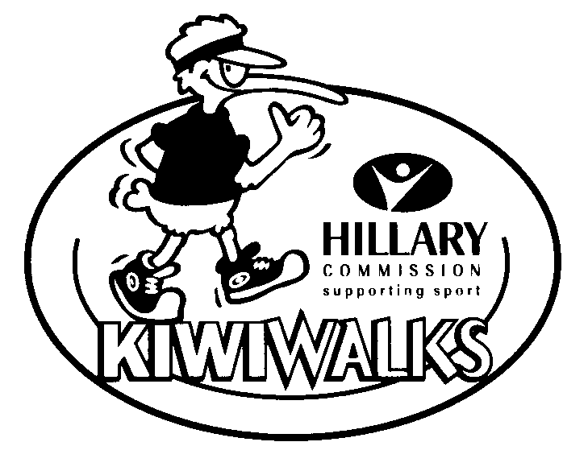



KIWIWALKS
Wellington Regional Council
October 1999

Sport Wellington Region would like to include the following walkways into the KiwiWalks programme. These walkways have been assessed and fit the criteria stipulated:
-Suitable for most ages and fitness levels
-Easily accessible
-Maintained by the regional council
-Free to public use
-Can be completed in an hour or less

We have identified two walkways at this stage but will continue assessing other walkways to add to the KiwiWalks programme

WALKWAY 1
Hutt River Trail
The section between Ewen Bridge and Melling Bridge. It is a round walk, up the west bank and back along the east bank.
Time 45 minutes
Parking at Sladden Park

WALKWAY 2
Tunnel Gully – Tane’s Track
Time 1 hour
Parking at lower carpark

We would like to launch the Wellington Regional Council KiwiWalks with the Hutt River Trail walkway. We hope to do this as part of the River Festival held on February 12 by Hutt City Council.

ACTIONS & RESPONSIBILITIES

Wellington Regional Council
-Assist in placing KiwiWalks signs on walkways
-Maintenance of signage
-Responsible for upkeep of the walking tracks as per usual
-Keeping a stock of brochures with other walkway brochures

Suggestion:
In the reprinting of brochures the KiwiWalks logo is included?

Sport Wellington Region
-Provide WRC with Perspex signs
-Co-ordinate a formal launch for one of the walks
-Promote walks to schools, walking groups, kohanga reos and the general public
-Award WRC with a KiwiWalks plaque
-Assess further walks

Compiled by

Natalie Baty

Sport Wellington Region

