Environmental Accreditation – Enviro-Mark®NZ Outline

The 5-step Enviro-Mark process tackles the implementation of each part of a credible EMS in a chronological fashion. We have incorporated Enviro-Mark®NZ within eMission so that participating businesses get this certification while working to improve their overall environmental performance.

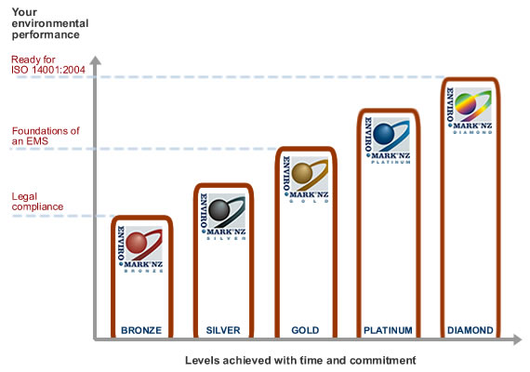

Bronze: Compliance with relevant health, safety and environmental legislation

Silver: Production of an appropriate environmental policy based on the identification of environmental aspects and impacts

Gold: Implementation and monitoring of continuous–improvement targets and objectives.

Platinum: Documentation of operational procedures and systems used to manage environmental aspects and impacts (e.g. work instructions, practices, training and communication, management review)

Diamond: Implementation of an internal management and audit programme to correct and drive continual improvement. [At Diamond level, a business is ready for an ISO14001 audit.]

Enviro-Mark®NZ Gold Businesses

We have worked with the following businesses in our previous programmes and they have now achieved the Enviro-Mark®NZ Gold certification.

Company | Location
Spicers Paper | Wellington
Thames Publications | Wellington
Label and Litho | Hutt
Pivotal Services | Wellington
Marketing Impact | Wellington
Lithoprint | Wellington
BRANZ | Porirua
Booker Spalding | Hutt
Wellington Business Forms | Wellington
Neale Print | Wellington
Astra Print | Wellington
Formway Furniture | Wellington
Formway Furniture | Hutt

We can provide contact details of these companies on request.

