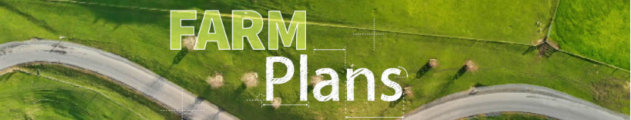
CERTIFIED FARM ENVIRONMENT PLAN

Farm Name:
Writer’s Name:
Date:
Catchment:
Certified by:

[Space to Insert picture from farm & remove Greater Wellington Logo]



1.0 Farm overview

1.1 Farm story
Farm history:

Farm system & management overview:

Farm goals:

1.2 Property details
Summary
Property name
Address
Name and contact details (email/phone)
Legal description of land
Legal description and ownership of land parcels (if different from above) | [i.e., lease block information & owner’s details]
Farm identifiers
Irrigation scheme and water permits
Other consents i.e., discharge

2.0 Catchment information

2.1 Catchment - Ruamāhanga Whaitua

2.2 Sub-catchment -

2.3 Challenges

Issue | Base grade | Objective
E-Coli
Periphyton
Ammonia toxicity
Nitrate toxicity
MCI

2.4 Community values

2.5 Farm focuses

3.0 Land mangement units & inherent vulnerabilities
Land Management Units (LMU’s) are areas of land that can be farmed or managed in a similar way because of underlying physical similarities. These LMU’s have been based on the following………

3.1 Farm map – land management units

[Insert map identifying all LMU’s]

3.2 Land Management Unit 1: Name

Description and management
Insert LMU map here

Inherent risks

Actions within this LMU

3.3 Land Management Unit 2: Name

Description and management
Insert LMU map here

Inherent risks

Actions within this LMU

3.4 Land Management Unit 3: Name

Description and management
Insert LMU map here

Inherent risks

Actions within this LMU

3.5 Land Management Unit 4: Name

Description and management
Insert LMU map here

Inherent risks

Actions within this LMU

3.6 Land Management Unit 5: Name

Description and management
Insert LMU map here

Inherent risks

Actions within this LMU

4.0 Farming activities & risk assessment [Section 4 is required to be completed by a certifier]

4.1 Introduction
In identifying the level of risk specific to a farm the lands inherent vulnerabilities must be considered alongside the farming or growing activities occurring. Any catchment context information relevant to each identified risk must also be considered. To fully understand the level, location and type of risks with potential mitigations the risk assessment is conducted at LMU scale.
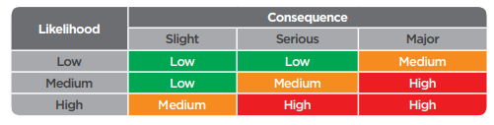
This table has been used to assist in the assessment of risks for each area (Nitrogen, Phosphorous, Sediment and E. Coli). For example, nitrogen through poor fertiliser application near a waterway has a serious consequence, and if the likelihood of it occurring is high then overall the risk is high, however if the likelihood is low then it is a low risk.

4.2 Nutrient management

4.2.1 Contaminants overview
Four key contaminants have been identified as problematic to New Zealand waterways: nitrogen (N), phosphorus (P), sediment, and E. coli.
The priority issue for my catchment is…………….
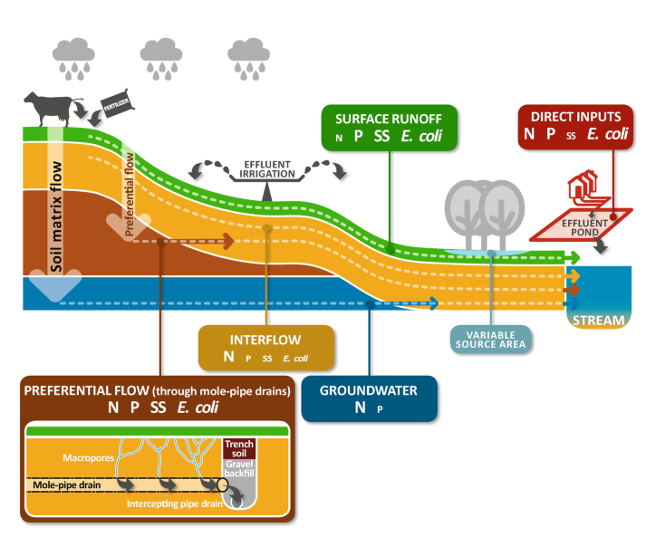
The greatest risk on this farm for that these contaminants could enter waterways are……………….

4.2.2 Nitrogen
Risk | Risk factors on your farm | Risk rating (High, Medium, Low)
Risk | Risk factors on your farm |  | Land Management Unit (LMU) or Paddock
Risk | Risk factors on your farm | Whole farm | 1: | 2: | 3: | 4: | 5:
Nitrogen loss risk  Nitrogen potentially entering waterways impacting freshwater health or drinking water quality | Animal loss risks: stock, feed type, grazing practices, off-paddock feeding | Low | Medium | High | N/A
 | Fertiliser loss risks: excessive nutrient levels (beyond plant needs), direct application to waterways
 | Effluent loss risks: overland flow, application beyond plant requirements
 | Nutrient transport risk: artificial drainage, soils, climate, topography, structural mitigations

Contaminant management and farm context:

4.2.3 Phosphorus / sediment / E. coli
Risk | Risk factors on your farm | Risk rating (High, Medium, Low)
Risk | Risk factors on your farm |  | Land Management Unit (LMU) or Paddock
Risk | Risk factors on your farm | Whole Farm | 1: | 2: | 3: | 4: | 5:
Sediment and Phosphorus loss risk  Sediment or phosphorus potentially entering waterways may cause excess algae growth, habitat loss or other harm to freshwater health | Erosion/Sediment loss risks: stock, grazing practices | Low | Medium | High | N/A
 | Cropping loss risks: cultivation
 | Fertiliser loss risks: excessive nutrient levels, direct application to waterways
 | Effluent loss risks: overland flow, application beyond plant requirements
 | Nutrient transport risks: artificial drainage, soils, climate, topography, structural mitigations
Faecal microbe loss risk  Contaminants, like pathogens such as E. Coli, potentially impacting on human health | Animal manure loss risks: stock, grazing practices
 | Nutrient transport risks: artificial drainage, soils, climate, topography, structural mitigations

Contaminant management and farm context:

4.3 Critical source areas

4.3.1 Critical source areas (CSA)

Point source areas

5.0 Action plan [Section 5 is required to be completed by a certifier]

5.1 Action plan table
Identified Risk | Action to address risk | Location / LMU/Paddock | Timeline | Person responsible | Budget | Priority | Regulatory/ Supplementary / Catchment | Evidence of completion | Date completed | Expected outcome

Project: | Stock Exclusion / Fencing Waterways |  |  |  |  | Time:
Area addressed: |  |  | Desired outcomes:
Tasks | Timeframe | Location: | Person responsible | People involved | Budget | Priority | Date completed | Evidence of completion

Regulations to consider prior to undertaking recommended works [Above Sch Z requirement]
Stock exclusion rules | Minimum setbacks and exclusion for new fences – GW stock-exclusion-regulations
Mechanical Management of Highly Modified Waterways | https://www.gw.govt.nz/document/18185/good-practices-for-the-mechanical-management-of-highly-modified-waterways/
Watercourse types | How to determine whether a watercourse is a river, ephemeral watercourse, highly modified river or stream, or artificial watercourse; https://www.gw.govt.nz/environment/land-use/watercourses/

6.0 Land Use & Stock Details

6.1 Farm summary
Summary | Dairy
Total Farm Area (ha)
Effective Farm Area (ha)
Irrigated Area (ha)
Dryland Area (ha)
Intensive Winter Grazing Area (ha)
Farm system/type
Climate:
Average rainfall (mm)
Average temperature (^{O}C)
Sunshine hours

6.2 Dairy
Summary
Peak cows milked
Cow breed
Once per day milking
Average milking cow live weight
Replacement rate
Milk solids per cow per year
Non lactating stock
[Description or general overview of current and intended future practise]

2 Sheep and Beef
Summary | Year
Peak Breeding Sheep numbers
Lambing %
Peak Cattle numbers
Calving %
Total Stock units
Sheep:cattle ratio
Stock units/grazeable ha
[Description or general overview of current and intended future practise]

6.3 Crop
Crop | Year | Year
Area (ha)
Yield (t DM/ha)
Month Sown
Cultivation Method
Month/s Harvested
Post Crop Treatment
Stock Grazing
[Description of current and intended future practise]

6.4 Other farm management practice

6.5 Farm Infrastructure
Type | Description
Culverts
Irrigation Pivot
Unmanaged crossings
Effluent Pond
Feed pad
Offal Pit
Silage stack
Yards
Old Sheds
Milk shed
Hay shed
Chemical storage
Fuel Storage
Fertiliser storage
Farm laneways / Tracks
Farm dump
Other

6.6 Nutrient Information
Block | Fertiliser product  (Month applied) | Rate of application  (kg/ha) | Nutrients applied (kg/ha)
 |  |  | N | P | K | S
 |  | Total Nutrient applied (kg/ha)
[Description or general overview of current and intended future practise]

6.7 Soil test
LMU | pH | Olsen P | Potassium |  | Potentially Available N (Crop Pdks)
1
2
3
4
5
[Overview of historic soil test levels and intended future levels you are wanting to increase, decrease or maintain]

6.8 Supplementary feed information
Feed type | Source | Amount (t DM) | Distributed location | Storage type
[Overview of where supplementary feed is sourced from, stored, how feed out and seasonal timing]

6.9 Irrigation Management
Water Permit/Consent Details -
Take type i.e. surface or groundwater
Expiry date
Maximum take (Monthly/Yearly)
Consented irrigation area (if applicable)
Any restrictions?
Natural Resources Plan
Efficient use criteria (Policy P118):
[Full details & conditions required]

Water Permit/Consent Details –
Take type i.e. surface or groundwater
Expiry date
Maximum take (Monthly/Yearly)
Consented irrigation area (if applicable)
Irrigation rate
Potential restrictions
Natural Resources Plan
Efficient use criteria (Policy P118):
[Full details & conditions required]

Irrigation Type | Pivot/Linear | Sprinklers (K-Line, Long-Line Sprinklers)
Irrigation Area (ha)
Rotation length
Application rate (mm)
Irrigation season start and end date
Decision making tools

6.10 Effluent Management
Consent/Permit details .
Expiry date:
Irrigation Area:
Application depth
Nitrogen loading
Other consent conditions of note
Effluent Management Details
Storage type (i.e. 2 pond system, solid separator to pond)
Storage volume m3
Storage days
Irrigator Type
Tested application depth mm
Fail safe/s
Notes:
[Full details & conditions required]

7.0 Farm maps
Map | Applicable (Yes or NA) | Map (name or number)
The property boundaries of the land being farmed
The boundaries of the main land management units or land uses on the land being farmed
The catchment and sub-catchment that the farm is within and a map showing the location of the farm within the sub catchment
Soil types and topography at 1:50,000 scale
The location (and for named waterbodies, the names) of any permanently or intermittently flowing waterbodies on the property including;
- rivers,
- streams,
- drains,
- wetlands,
- lakes, and
- springs, and
- specifically identifying any waterbodies that meet the criteria for stock exclusion in the Regional Plan and/or Resource Management (Stock Exclusion) Regulations 2020
The location of any site or river included in Schedules B, C, F1 and F3 of the Plan that is within, or adjacent to, the property
The location of riparian vegetation and fences (or other stock proof barriers adjacent to water bodies)
The location of any stock crossing points or structures on any water bodies where stock have access
The location of any critical source areas, and hotspots for contaminant loss to groundwater or surface water
The location of any surface and (where known) sub-surface drains
The location(s) of the actions and practices that will be adopted to ensure the effective management of contaminant loss on the farm [Required to be completed by a certifier]
Any other feature or characteristic of the land necessary to assess the risk factors set out in Tables 1 to 3;
- Effluent applications including liquids and solids
- Animal types
- Erosion/sediment issues
- Cropping areas

7.1 Farm map – Sub-catchment

7.2 Farm map – Soils

7.3 Farm maps – Waterways and sites of significance

7.4 Farm map –Waterway types and crossings

7.5 Farm map –Riparian planting

Farm map –Critical source areas

7.7 Farm map – Infrastructure

8.0 Appendix A – Dairy Farm Mitigations/Good Management Practices (GMPs)
Risk | Mitigation/GMP
Soil structure degradation, including erosion through run-off, and wind blow. Soil compaction, e.g., pugging
Nutrient contamination to waterways
Nutrient loss
Nutrient loss
Nutrient loss
Nutrient loss
Nutrient loss
Nutrient loss
Nutrient loss
Soil damage/compaction.
Nutrient, sediment, e.coli loss
Nutrient, sediment, e.coli loss
Nutrient loss
Rubbish
Contaminant loss to waterways
Contaminant loss

9.0 Soil Nutrient Risk Table
Identifying and understanding soil type’s and their limitation is important, these should be accounted for when making land management decisions.
Soil Sibling  [Soil map colour] | Common Names | LMU’s | Drainage Class | Structure & Leaching | Texture

10.0 Appendix B – Catchment information

